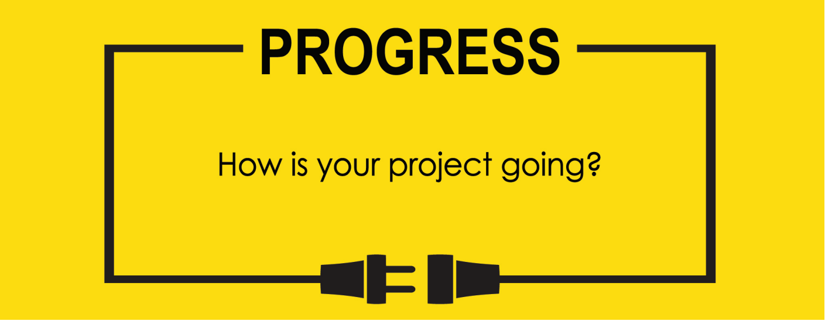

**Name: Zach Wilcox**

**Project Title: GreenBox**

**Previous Goals**

What were your three goals from last week? Were you able to complete them? If so, select Completed. If not, select the level of completion and explain in the Notes section why the goal was not completed, what still remains to be done, and when you expect to finish work on the goal.

Goal #1 from last week: Finish box build

**Status:** _____Completed ___x__Partially Completed _____No Progress

**Notes:**

I spent most of the week very sick and was thus unable to get the adhesives and other small but important pieces needed to assemble the box as well as not feeling good enough to work on it as much as I would have liked. However, the larger pieces are shaped correctly and simply require assembly.

Goal #2 from last week: Finish initialization code for MCU

**Status:** __X___Completed _____Partially Completed _____No Progress

**Notes:**

**The initialization code for the MCU has been completed, so the individual control portions of code and timers/interrupts remain.**

Goal #3 from last week: Begin GPIO control code.

**Status:** _____Completed __x___Partially Completed _____No Progress

**Notes:**

Marked partially completed, as the GPIO control code is not completed, though it has been started. Much of the control depends on timers and analog input from the potentiometers, which have not yet arrived (they have been shipped) so this portion cannot be completed until other parts have been finished.

**Next Three Goals**

Choose three subtasks from your Gantt chart and use them to form goals that you plan to complete this week. In the text box beneath each goal, give details about what you plan to accomplish. Include details such as what materials are needed, how many hours each day you plan to devote to the task, and so on.

NOTE: THESE ARE INDIVIDUAL GOALS THAT YOU PLAN TO ACCOMPLISH. THESE ARE NOT TEAM GOALS.

**Goal #1:** Finish box build

**Goal #2:** Code needed timers

**Goal #3:** get knob/potentiometers and assemble those circuits for use in GPIO control code

LCD code being tested on the on-board LCD. Displaying a timer that is not finished for use in the project.

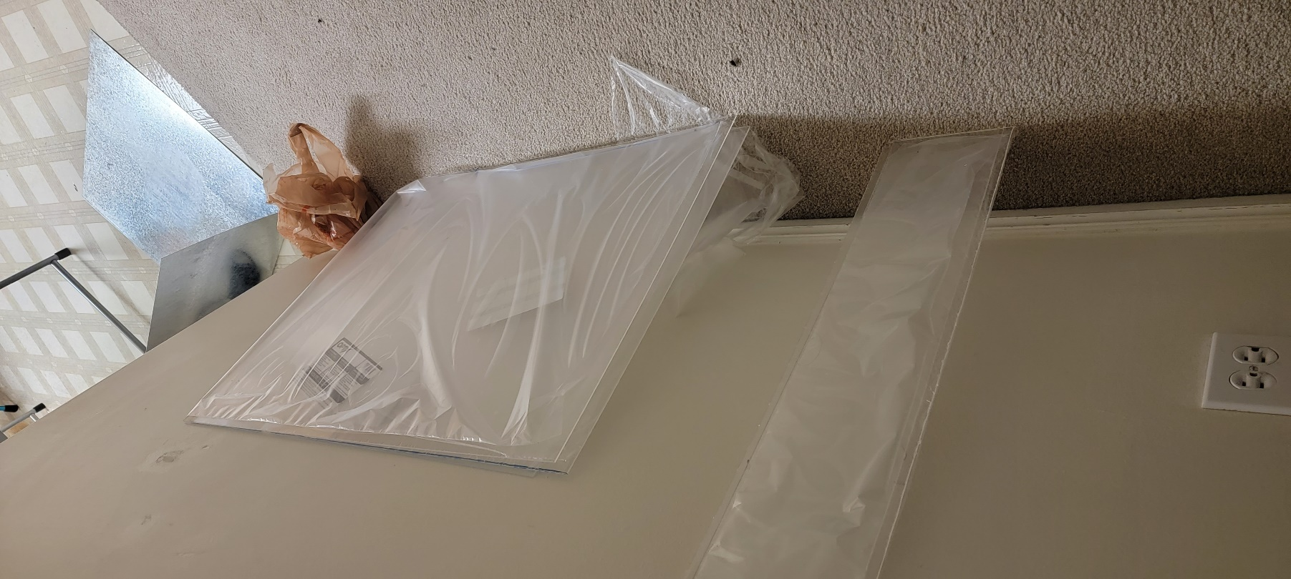The acrylic and metal pieces cut to size and various hardware. Still needing to be assembled.

Previous Gantt chart

Updated Gantt chart. Box assembly has been extended to last longer.